CURRICULUM VITAE
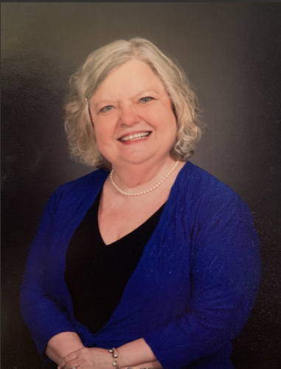
DENISE M. SHAHAN
La Fayette GA 30728
Mobile: 423-304-7019
Email: dshahan.with.pen.in.hand@gmail.com LinkedIn: Denise Manley Shahan

Objective: To work as a Freelance Creative Writer/Editor

Summary of Qualifications:
- Creative writing education and experience
- Experienced healthcare administrator
- Strong problem-solving skills
- Proficient in Microsoft Office, Google Office, Adobe, Access, PowerPoint
- Knowledge, skills, and assessment ability for innovation in varied projects
- Strong people skills

Work Experience:

Internship, GoodNews Christian Magazine, Cleveland, TN Summer Semester 2023
As a Rhetoric and Writing student minor, I serve as an intern with ENGL 4700, English
Internship. Complete magazine operations from start to finish are covered. The main areas of concentration include editing, writing, establishing a database of writers, updating prospects for market area sales and outreach, brainstorming online methods of reaching readers, and growing the magazine’s outreach through readership.

Retired, La Fayette GA 2010-Present
I volunteer in community activities and projects, have spearheaded committees, and
emceed programs. Currently, I designed a proposal for a community educational tutoring initiative. Additionally, I returned to college to complete a B.S. in Organizational Leadership in Healthcare Administration, with a minor in Rhetoric and Writing.

*Communication *Team Building
*Organizational management *Computer Systems applications
*Creative writing skills *Extrovert/People skills

CHI Memorial Healthcare/Mountain Management Services, Chattanooga TN 1978-2010
What began as a single medical practice that I managed later combined with a physician/hospital organization (PHO) with over 40 medical practices. As a Regional Manager in administration, I was responsible for training/teaching staff in the current processes of billing, patient coordination, medical records organization, coding, and scheduling. As a member of the administrative team, I developed policy and procedure manuals, coordinated projects, performed financial analyses, wrote initiative plans, practice brochures, evaluations, and various reports, assisted with physician’s “fit” in specific practices as part of the recruiting process, provider credentialing, and handled PHO physician liaison and other management nuances of a multi-million-dollar business.
CHI Memorial Healthcare/Mountain Management Services, Chattanooga TN (Continued)
*Team development/enhancement *Human Resources issues
*Wrote/developed/taught classes in coding, customer service, budgeting, etc.

Athens General Hospital (now Piedmont Athens Regional), Athens GA 1972-1976
Serving as Executive Administrative Assistance to the Director of Medical Affairs, I
was responsible for data files of EKG interpretations, scheduling How to Interpret EKGs
classes with hospital staff, MSN students with Medical College of Georgia, UGA School
of Pharmacy students; scheduling, notices, and summary of monthly Tumor Conferences
for medical staff and MSN students; scheduling and maintaining Emergency Room
Physician work schedules; updating and maintaining medical staff databases, including
office and personal contact information; transcription of all correspondence, patient
consults, new policies and procedures for ICU/CCU, Emergency Room, Respiratory
Therapy, and other physician-directed hospital departments; supportive assistance to two
in-house MSNs whose Georgia Rural Nurses’ Association encompassed twelve rural
hospitals in the multi-county northeast Georgia region; ensuring Joint Commission
compliance and updates for physician-directed hospital departments, maintaining files
and manuals for each; and other duties as liaison with physicians and the Department
of Medical Affairs.

Education:
Dalton State College, Dalton GA B.S., Organizational Leadership, Healthcare Administration,
Minor: Rhetoric and Writing 2021-2023
A.S., Business Administration, Healthcare 1970-1972

The University of Georgia, Athens GA eCore/eMajor Classes to B.S. 2021-2023
Core Curriculum Classes 1974

Career and Current Affiliations/Honors:
Sigma Tau Delta International English Honor Society; Phi Theta Kappa National Honor Society; Works published in Exemplar, literary journal, and Tributaries, arts journal, Dalton State College; Dalton Junior College Student Union, Past Secretary; Honors Graduate 1972 and 2023; Local Business and Professional Women’s Club (BPW) Young Careerist Winner; Georgia BPW State Young Careerist, First Runner Up; North LaFayette PTO, past President; Beta Sigma Phi International Women’s Sorority, Charter Member, Theta Xi, LaFayette Chapter, Lifetime Membership, all offices held; LaFayette Highland Club Charter Member, past President; LaFayette First Baptist Church, Women on Mission, Women of Faith, Ladies’ Handbell Choir, and Adult Choir member; Finalist, Southeastern Writers’ Association Conference Contest, 2023, second place, The Lowcountry Excellence in Writing Award, and The Young Reader’s Award; Medical Group Management Association (MGMA); Tennessee Medical Group Management Association (TMGMA); Northwest Georgia Medical Managers’ Group; Floyd Medical Center Managers’ Group; Northwest Georgia Technical College Business Education Board member; LaFayette High School Health Occupations (HOSA) Board member; and, The Walker County Chamber of Commerce, Board and Executive Board member, past Secretary.

*References available on request

